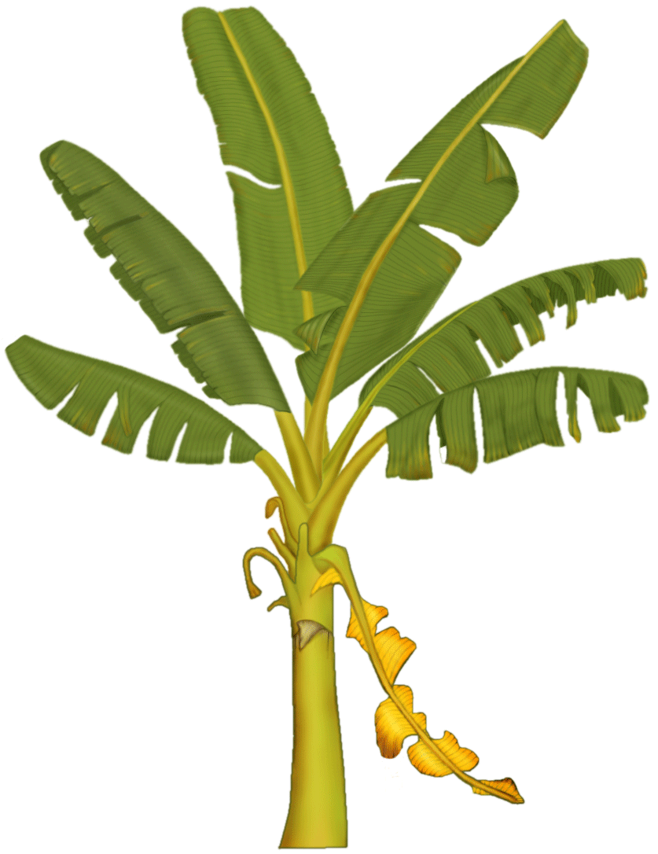
Banana Circle Needs and Yields Analysis
NEEDS
YIELDS

