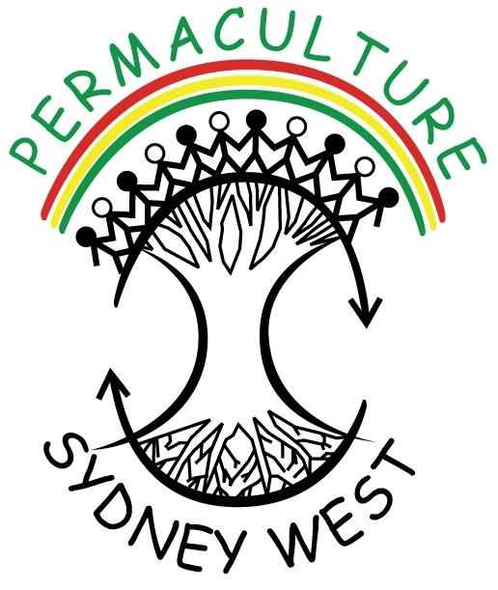

Permaculture Sydney West Inc.
Notice of Annual General Meeting

The AGM of Permaculture Sydney West will be held on Monday 5th December 2016 at
Wentworthville Community Centre - 2 Lane Street Wentworthville, NSW 2145
Meeting commences at 7.00 pm, followed by the AGM.

The business of the meeting shall be to:
1] Confirm the minutes of the Annual General Meeting held in 2015.
2] Receive the President’s, Secretary’s and Treasurer’s Reports and activities throughout 2015.
3] Announce the nominations for committee positions for the next 12 months.
4] General Business.

_________________________________________________________________________________________

Nomination

Position Title: Signature:

Name of Nominee: Signature:

Proposed by: Signature:

By signing, I the nominee, agree to my nomination and accept my commitment for the above position, if I am elected for the term.
__________________________________________________________________________

All positions will be declared vacant at the meeting. Positions to be filled are:

- President **
- Vice President **
- Treasurer **
- Secretary **
- Membership Team
- Web Team
- Media/ Marketing Team
- Marketing Team
- Garden Team
- Education Team
- Living Skills Team
- Seed Savers Team
- Library Team
- General Support Team(includes tea/Coffee person)

** Office Bearer Positions that must be filled at the AGM.

Please refer to specific job role descriptions. (Available on PSW website)
Positions are from 1 January 2017 until 31 December 2017 [12 months].
If there is more than one nominee for a position, a majority vote may take place.
Nomination forms for a position on the Committee must be signed by a nominee who is a financial member of Permaculture Sydney West Inc.
Nominations close on Friday 2nd December 2016.

Please complete this form, scan or print, and then return to the Secretary by:
Email: informationpsw@gmail.com
Thank you for your Nomination.

